8)Study and installation of packet tracer and its features:-
Introduction:-
- Packet tracer is very useful cisco network simulation tool which is developed by dennis frezo and his team at cisco systems.
- Packet tracer is a powerful and dynamic tool that displays the various protocols in networking, in either real time or simulation mode.
- Packet tracer performs simulation for routers , switches and related network devices.
- The user interface of the packet tracer is pretty user-friendly and allows to drag and items form item display section to main simulation window.
- Packet tracer includes layer 2 protocols:Ethernet, PPP etc.,
- Layer3 protocols: IP,ICMP,ARP,RARP,
- Layer4 protocols: TCP,UDP etc., all these protocols can be traced and simulated in packet tracer.

Installation of a Packet Tracer:-
Step:-1 After CISCO packet tracer download. Click on the downloaded exefile below window will appear click the next option.

Step:-2 On the next screen select “ I Accept the agreement and click on next”

Step3:- Setup will show the folder in which the programs shortcut will be created.
If you want to change the folder you can change it . click on next
Step4:- Then the program will ask whether to create a desktop icon and create a quick launch icon. Make your choice on Next

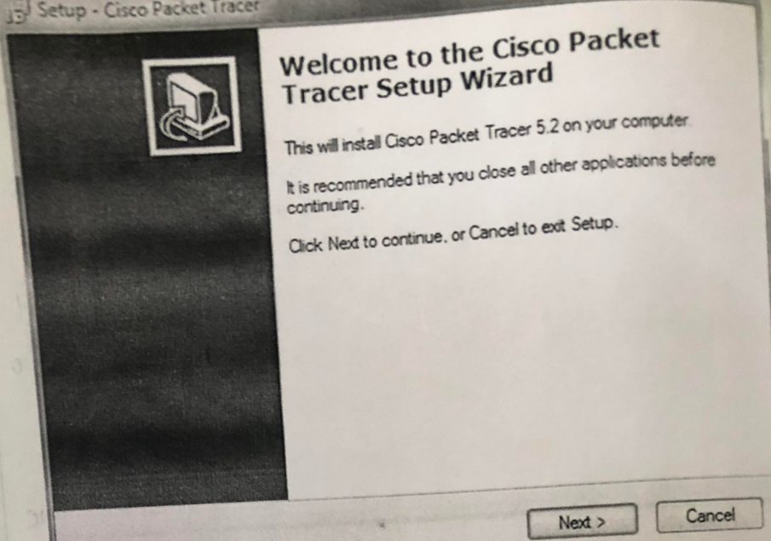

Step5:-
The summary of the settings we selected is displayed . click on Install
Step6:-
The CISCO packet tracer installation starts as shown in fig
Step7:-
CISCO packet tracer installation gets completed and the screen is shown
Click on finish
Click “OK” on next pop up asking you to close or restart your computer.
Step8:- Packet tracer is installed and ready to be used.
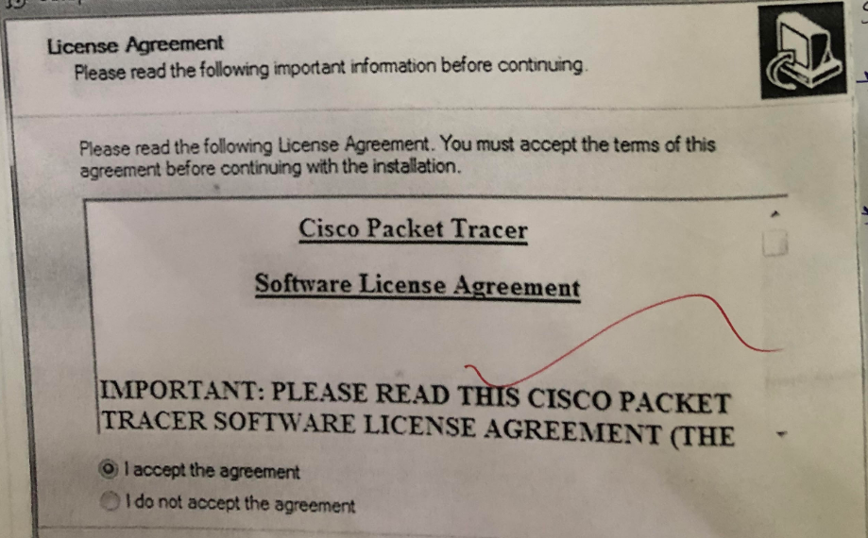

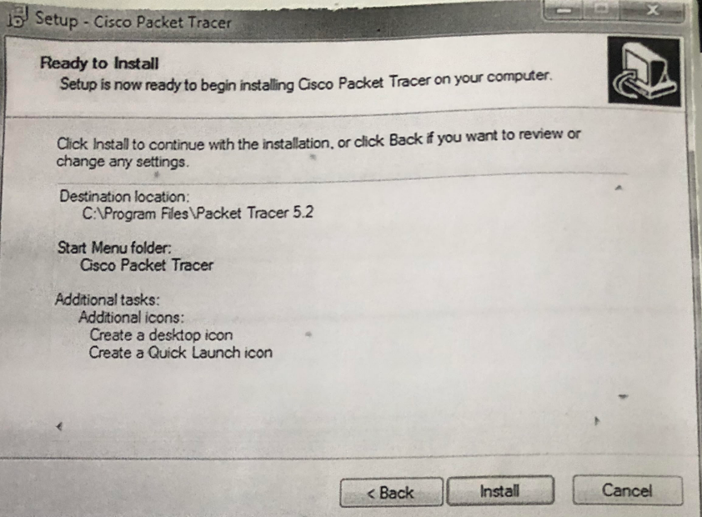

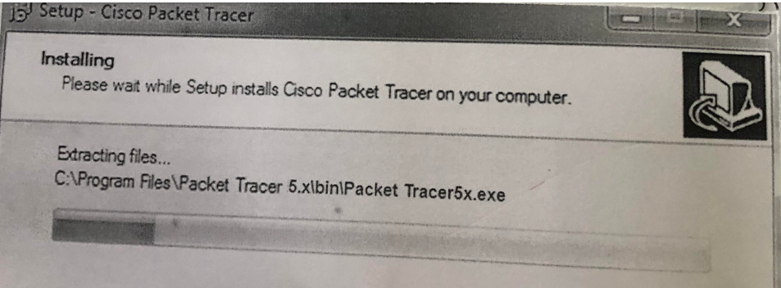
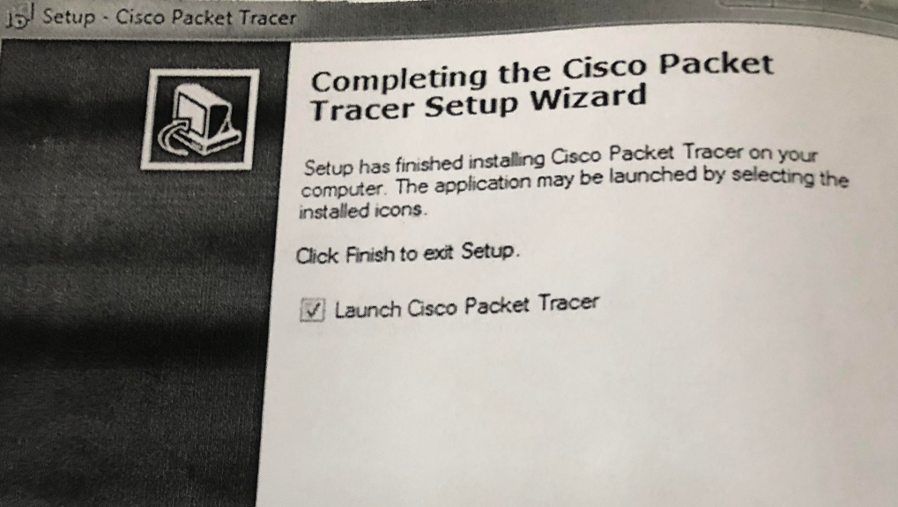
Features:-
- Customize single or multiuser activities
- Interactive environment
- Visualizing Network
- Realtime mode and simulation mode
- Supports majority of networking protocols
- Provides visual demonstration of network technologies

Protocols:-
CISCO packet tracer supports the following protocols
Layer | CISCO Packet tracer supported Protocols
Application | FTP,SMTP,HTTP,TELNET,SNMP
Transport | TCP,UDP,SCTP
Network | ICMP,IGMP,IP,RARP,ARP
Network Access/Interface | Ethernet 802.3,802.11, HDLC, Frame Relay,

9) Implementation of Network topologies using packet tracer :
a)Implement star topology with a hub
- Introduction:- Network Topology is the arrangement of nodes of a computer network
- It can also be viewed as a layout of a computer network.
- Physical topology means placement of various node
- Logical topology means it deals with the dataflow in the network.
- Various types of network topologies are: Bus, Ring, Star, Mesh and Hybrid
Star topology:-
- Every node is connected to a central node called a Hub/Switch
- Centralized Management
- All traffic must pass through the hub/switch
Advantages:-
- Easy to design and implement
- Centralized administration
- Scalable
Disadvantages:-
- Single point of failure effects the whole network
- Bottle Neck overloaded switch/Hub
- Increased cost due to switch

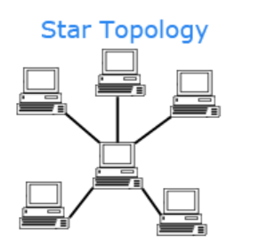
Procedure for star topology:-
- Start the packet tracer
- Chooe the devices and connections devices like end devics, hubs,switches,connections etc.,
- Build the topology by connecting devices like host, hubs
- Configure IP address and subnet mask on the host
- Connect all hosts(host0,host1,host2, host3 etc.,) to hub0
- Verify connectivity in real time mode
- Verify connectivity in simulation mode
- Save the topology

Aim:- To broadcast a packet through hub
- Select hub from network devices section and place it in a environment
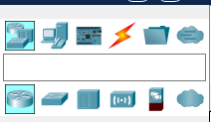
Network device section
Select hub

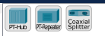
Select pc-hub
- From end device section select computers
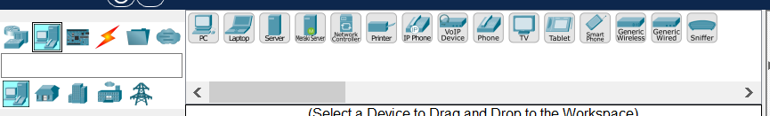
End device section
Select PC

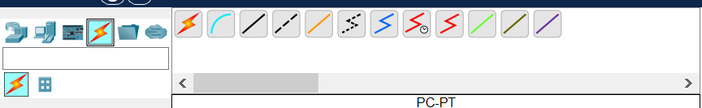3)
Select connections
Select automatically choose connection type
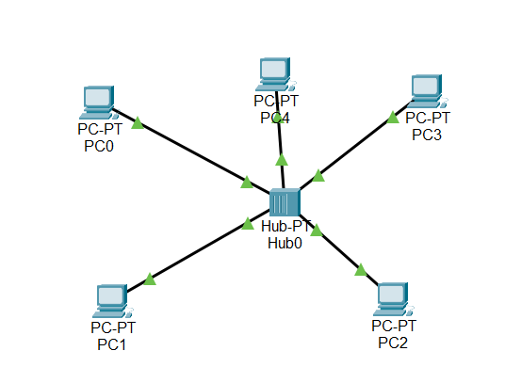
Connections are established we need to assign IP addresses. Select computer click on desktop --→ip config
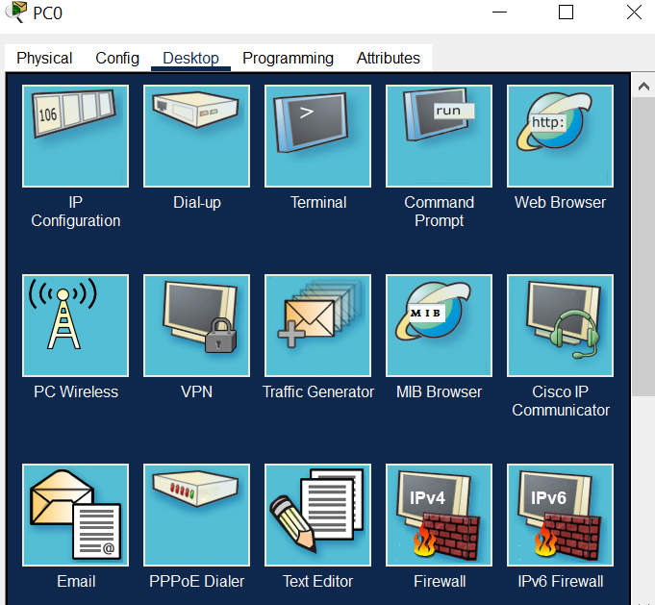

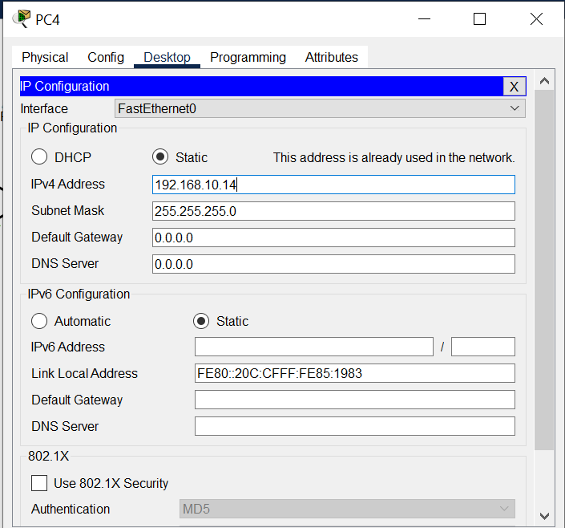

4) I want to transmit a pdu from PC0 to PC4 . select pdu place it from source to destination and then select simulate in the environment

